# Exercise

# Create a pipeline for your package

Here you'll get the team's new code for the Tailspin.SpaceGame.Web.Models project that is now separate from the Tailspin.SpaceGame.Web project. You'll create a Microsoft Azure Pipelines project for the Models project, and see the artifact in Microsoft Azure Artifacts with a version number of 1.0.0 in your feed.

## What changes were made to the project?

Recall that the Space Game website is an ASP.NET Core application. It uses the Model-View-Controller (MVC) pattern to separate data from how that data is displayed in the user interface. Andy and Mara want to move the model classes to a separate library so that multiple projects can use those classes.

To do that, they create a new C# project, called **Tailspin.SpaceGame.Web.Models**, that contains only the model classes. At the same time, they remove the model classes from their existing project, **Tailspin.SpaceGame.Web**. They replace the model classes in their existing project with a reference to the **Tailspin.SpaceGame.Web.Models** project.

To build these projects, Andy and Mara use two pipelines, one for each project. You already have the first project and its associated Azure Pipelines configuration. Here, you'll fork the second project on GitHub, and create an Azure Pipelines configuration to build it. You'll publish the resulting package to Azure Artifacts.

## Prepare Visual Studio Code

Set up Visual Studio Code so you can work with source files.

1. From Visual Studio Code, open the integrated terminal.
2. Go to a directory to work from, such as your home directory (~). We suggest using the parent directory from where your **mslearn-tailspin-spacegame-web** project is located.

## Get the source code

Get the source code for the second project from GitHub, and set up Visual Studio Code so you can work with the files.

### Create a fork

The first step is to fork the **mslearn-tailspin-spacegame-web-models** repository so you can work with and modify the source files. Recall that Mara put the **Models** directory in a new project, and removed it from the web project.

To fork the **mslearn-tailspin-spacegame-web-models** project into your GitHub account:

1. From a web browser, go to GitHub  and sign in.
2. Go to the mslearn-tailspin-spacegame-web-models  project.
3. Select **Fork**.
4. Follow the instructions to fork the repository into your account.

### Clone your fork locally

To clone the **mslearn-tailspin-spacegame-web-models** projects to your computer:

1. Go to your fork of the **mslearn-tailspin-spacegame-web-models** project on GitHub.
2. Select **Clone or download**. Then select the button next to the URL that's shown to copy the URL to your clipboard.
3. From Visual Studio Code, go to the terminal window and run this git clone command. Replace the URL that's shown with the contents of your clipboard.

**Bash**

**git clone https://github.com/your-name/mslearn-tailspin-spacegame-web-models.git**

1. Move to the **mslearn-tailspin-spacegame-web-models** directory. This is the root directory of your repository.

**Bash**

**cd mslearn-tailspin-spacegame-web-models**

### Open the project and examine the configuration

In Visual Studio Code, your terminal window points to the root directory of the **mslearn-tailspin-spacegame-web-models** project. Open the project from the file explorer so that you can view its structure and work with files.

1. From the **File** menu, select **Open**.
2. Go to the root directory of the **mslearn-tailspin-spacegame-web-models** project.

You see the directory and file tree in the file explorer.

1. Open the azure-pipelines.yml file.

You see the steps where the package is built, the version is set, and the package is added to Azure Artifacts.

This DotNetCoreCLI@2 task builds the project:

**yml**

- task: DotNetCoreCLI@2

displayName: 'Build the project - $(buildConfiguration)'

inputs:

command: 'build'

arguments: '--no-restore --configuration $(buildConfiguration)'

projects: '**/*.csproj'

This DotNetCoreCLI@2 task packages the project with a version of 1.0.0:

ymlCopy

- task: DotNetCoreCLI@2

displayName: 'Pack the project - $(buildConfiguration)'

inputs:

command: 'pack'

projects: '**/*.csproj'

arguments: '--no-build --configuration $(buildConfiguration)'

versioningScheme: byPrereleaseNumber

majorVersion: '1'

minorVersion: '0'

patchVersion: '0'

When developing your package, it's common to use the byPrereleaseNumber versioning scheme. This appends a unique pre-release suffix, such as "-CI-20190621-042647" to the end of the version number. Following this example, the complete version number would be "1.0.0-CI-20190621-042647".

This NuGetCommand@2 task pushes the package to your **Tailspin.SpaceGame.Web.Models** Azure Artifacts feed:

ymlCopy

- task: NuGetCommand@2

displayName: 'Publish NuGet package'

inputs:

command: push

publishVstsFeed: 'Space Game - web - Dependencies/Tailspin.SpaceGame.Web.Models'

allowPackageConflicts: true

condition: succeeded()

## Create the pipeline in Azure Pipelines

You learned how to set up Azure Pipelines in an earlier module. If you need a refresher, head over to Create a build pipeline with Azure Pipelines .

Since your solution has just the one project in it, the scope of the job agent is limited and cannot access the package. To make sure the agent has the permissions it needs to publish the artifact, you need to turn off **Limit job authorization scope to current project** in the pipeline settings.

To turn off this setting:

1. In Azure DevOps, navigate to your organization.
2. Select **Organization settings** from the bottom corner.
3. Under **Pipelines**, select **Settings**.
4. Turn off **Limit job authorization scope to current project**.

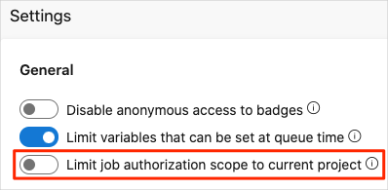

You need to make a similar change to your project:

1. From Azure DevOps, go to the **Space Game - web - Dependencies** project.
2. Select **Project settings** at the bottom left.
3. Under **Pipelines**, select **Settings**
4. Turn off **Limit job authorization scope to current project**.

Next, you'll set up a second pipeline to build the package and upload that package to Azure Artifacts.

1. From Azure DevOps, go to the **Space Game - web - Dependencies** project.
2. Select **Pipelines**, from the menu on the left.
3. Select **+ New Pipeline**.
4. From the **Connect** tab, select **GitHub**.
5. From the **Select** tab, select **mslearn-tailspin-spacegame-web-models**.

If prompted, enter your GitHub credentials. From the page that appears, scroll to the bottom and select **Approve and install**.

1. From the **Review** tab, you see the new pipeline's azure-pipelines.yml file.
2. Select **Run**.
3. Watch the pipeline run.
4. Go to the **Artifacts** tab.
5. From the dropdown at the top, select **Tailspin.SpaceGame.Web.Models**.

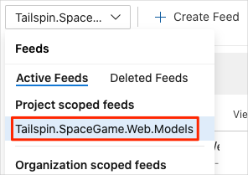

You see the resulting package, **Tailspin.SpaceGame.Web.Models**, in Azure Artifacts.

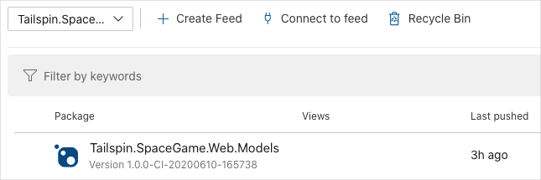

1. Select the package to go to the details page. Then copy the version number to a location where you can easily access it later.

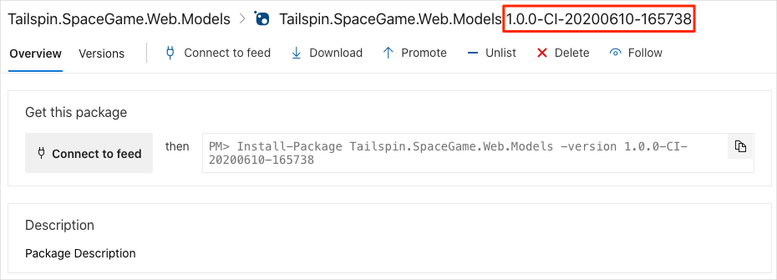

You'll use this version number in the next part.